Punjab University College Of
Information Technology



Submitted to: Sir Asif Sohail
Submitted by: Abdul Aziz BCSF19A026
Fatima Ansari BCSF20A046
Submission Date: 1st ^{February}

HOSPITAL MANAGEMENT SYSTEM

INTRODUCTION:

The hospital management system is a computer-based system that facilities managing the functioning of a hospital to make the whole functioning paper less.
The hospital database includes all the necessary patient data. The disease history, lab reports, prescribed treatment can be accessed by doctors without much delay in order to make an accurate diagnosis and monitor the patient's health. It enables lower risks of mistakes.
The project Hospital Data Management System (MDBS) is for computerizing the working in a hospital. It takes care of all the requirements of an average hospital and is capable to provide easy and effective storage of information related to patients that come up to the hospital. It generates test reports, provide medicines prescribed to patient and doctor. It also provides billing facility on the basis of patient’s status whether it is an indoor or outdoor patient. The system also provides the facility of backup as per the requirement.

ERD OF THE SYSTEM:
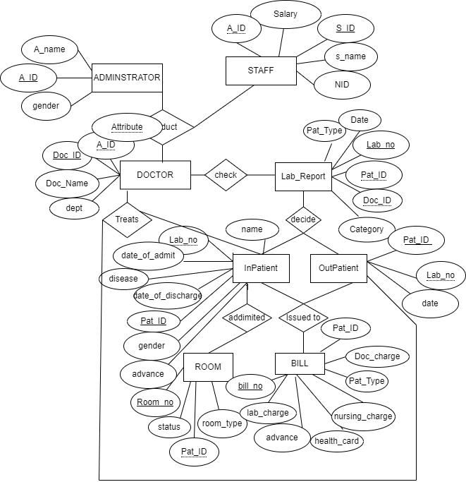

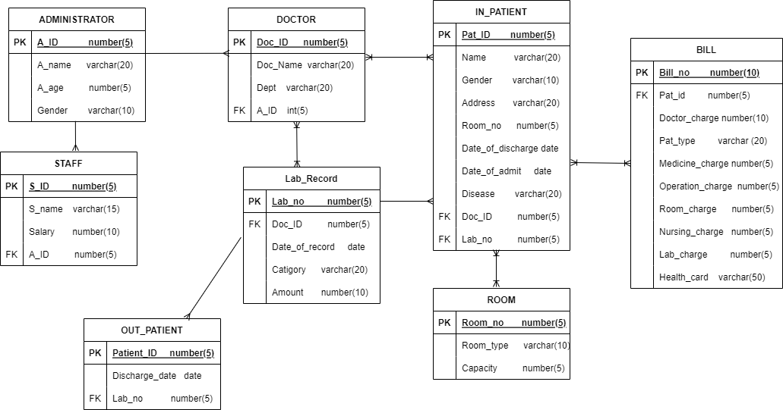

RELATIONAL SCHEMA:

ADMINISTRATIVE (A_ID, A_Name, A_age, Gender)
DOCTOR (Doc_ID, Doc_Name, Dept, A_ID)
ROOM (Room_no, Room_type, Capacity)
LAB_RECORD (Lab_no, Doc_ID, Date_of_record, Category, Amount)
IN_PATIENT (Pat_ID, Name, Gender, Address, Room_no, Date_of_discharge, Date_of_admit, Disease, Doc_ID, Lab_no)
BILL (Bill_no, Pat_ID, Doctor_charge, Pat_type, Medicine_charge, Operation_charge, Room_charge, Nursing_Charge, Lab_charge, Health_Card)
STAFF (S_ID, S_name, Salary, A_ID)
OUT_PATIENT (Pat_ID, Discharge_Date, Lab_no)

Relational Schema is already in normalized form.Because all normal form are satisfied.
These all relation 1NF (because there is no multi value attribute), 2nd normal form (because there is no partial functional independency) ,3rd normal form (because there is transtitive attribute)and BCN form.

1. Administrator Table:
Fields Data Type Relationships
a_id int(5) Primary Key
a_name Varchar(20) Not Null
a_age int (5)
gender Varchar(10) Not Null

2. Doctor Table:
Fields Data Type Relationships
Doctor_id int(5) Primary Key
Doctor_name Varchar(15) Not Null
Dept Varchar(15) Not Null
a_id Int(5) Foreign Key

3. Staff Table:
Fields Data Type Relationships
s_name Varchar(15) Not Null
s_id Int(5) Primary Key
salary Int(5) Not Null
a_id Int(5) Foreign Key

CREATION AND DESCRIBTION OF ALL TABLES:

4. Lab table:
Fields Data Type Relationships
lab_no int(5) Primary Key
Doctor_id int(5) Foreign Key
date Date/Time[6] Not Null
category Varchar(15) Not Null
amount Int(10) Not Null

5. Inpatient Table:
Fields Data Type Relationships
Patient_id int(5) Primary Key
name Varchar(20) Not Null
gender Varchar(10) Not Null
address Varchar(20) Not Null
room_no int(5) Not Null
date_of_admit Date/Time[ 6] Not Null
date_of_discharge Date/Time[6 ] Not Null
lab_no int(5) Foreign Key
Doctor_id Int(5) Foreign Key
disease Varchar(20) Not Null

6. Outpatient Table:
Fields Data Type Relationships
Patient_id int(5) Primary Key
date Date/Time Not Null
lab_no int(5) Foreign Key

7. Room Table:
Fields Data Type Relationships
room_no Int(5) Primary Key
room_type Varchar(10) Not Null
capacity int(10) Not Null

8. Bill Table:
Fields Data Type Relationships
bill_no int(50) Primary Key
patient_type Varchar(10) Allow Null
doctor_charge int Not Null
medicine_charge int Not Null
room_charge int Allow Null
operation_charge int Allow Null
number_of_days int Allow Null
nursing_charge int Not Null
health_card Varchar(50) Allow Null
lab_charge int Allow Null

CREATE TABLE ADMINISTRATOR
(
A_ID NUMBER(5),
A_name VARCHAR(20) NOT NULL,
A_age NUMBER(5),
Gender VARCHAR(10) NOT NULL,
constraint ACT_A_ID_PK primary key (A_ID)
);
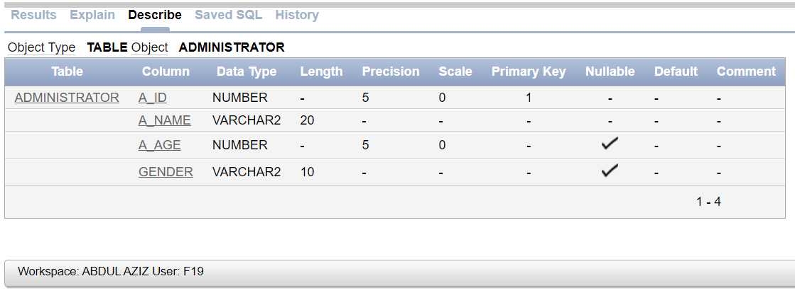

CREATE TABLE STAFF
(
S_ID NUMBER(5),
S_name VARCHAR(15) NOT NULL,
Salary NUMBER(10) NOT NULL,
A_ID NUMBER(5),
constraint STAFF_A_ID_FK foreign key (A_ID) references ADMINISTRATOR(A_ID),
constraint STAFF_S_ID_PK primary key (S_ID)
);
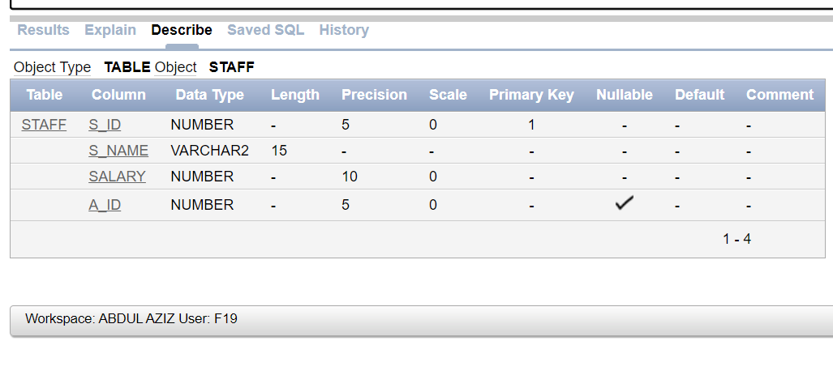
CREATE TABLE DOCTOR
(
Doc_ID NUMBER(5),
Doc_Name VARCHAR(20) NOT NULL,
Dept VARCHAR(20) NOT NULL,
A_ID NUMBER(5),
constraint DOC_Doc_ID_PK primary key (Doc_ID),
constraint DOC_A_ID_FK foreign key (A_ID) references ADMINISTRATOR(A_ID)
);
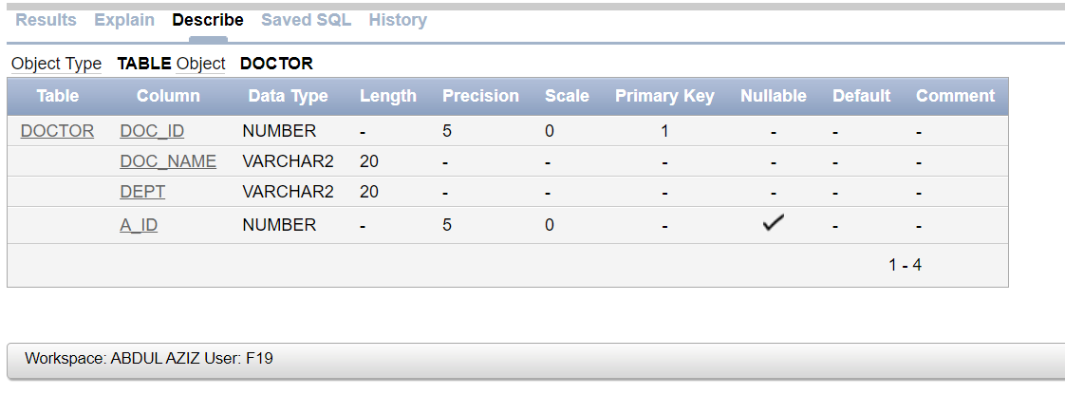
CREATE TABLE OUT_PATIENT
(
Patient_ID NUMBER(5),
Discharge_date date default sysdate,
Lab_no NUMBER(5),
constraint OP_Patient_ID_pk PRIMARY KEY (Patient_ID),
constraint OP_Lab_no_FK FOREIGN KEY (Lab_no) REFERENCES LAB_RECORD(Lab_no)

);
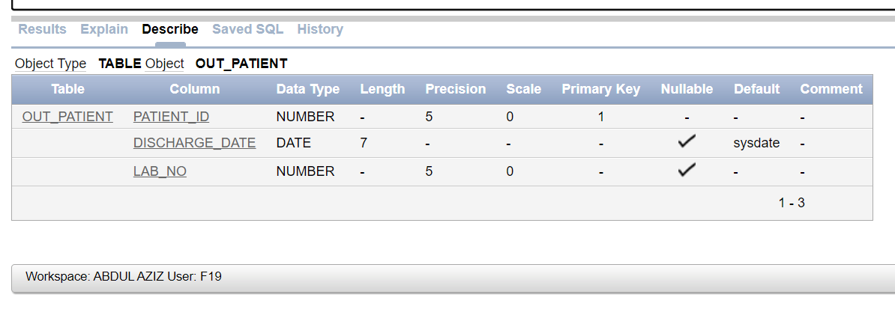
CREATE TABLE LAB_RECORD
(
Lab_no NUMBER(5),
Doc_ID NUMBER(5) NOT NULL,
Date_of_record date default sysdate,
Catigory VARCHAR(20),
Amount NUMBER(10) NOT NULL,
constraint Lab_Lab_no_pk PRIMARY KEY (Lab_no),
constraint Lab_Doc_ID_fk FOREIGN KEY (Doc_ID) REFERENCES DOCTOR(Doc_ID)
);
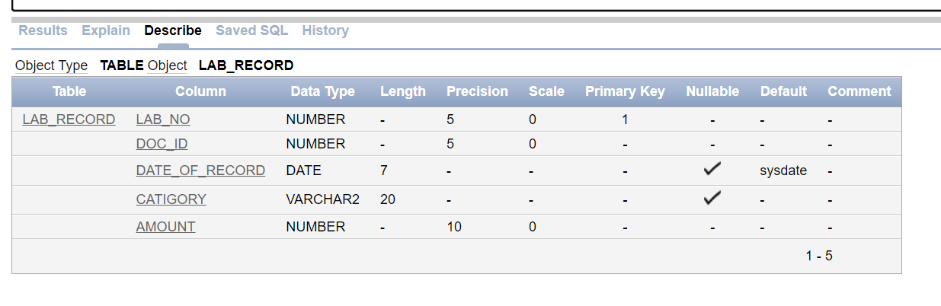

CREATE TABLE IN_PATIENT
(
Pat_ID NUMBER(5),
Name VARCHAR(20) NOT NULL,
Gender VARCHAR(10) NOT NULL,
Address VARCHAR(20) NOT NULL,
Room_no NUMBER(5),
Date_of_discharge date default sysdate,
Date_of_admit date default sysdate,
Disease varchar(20),
Doc_ID NUMBER(5) NOT NULL,
Lab_no NUMBER(5) NOT NULL,
constraint IP_Pat_ID_PK PRIMARY KEY (Pat_ID),
constraint IP_Room_no_FK FOREIGN KEY (Room_no) REFERENCES ROOM(Room_no),
constraint IP_Lab_no_FK FOREIGN KEY (Lab_no) REFERENCES LAB_RECORD(Lab_no),
constraint IP_Doc_ID_FK FOREIGN KEY (Doc_ID) REFERENCES DOCTOR(Doc_ID)
);
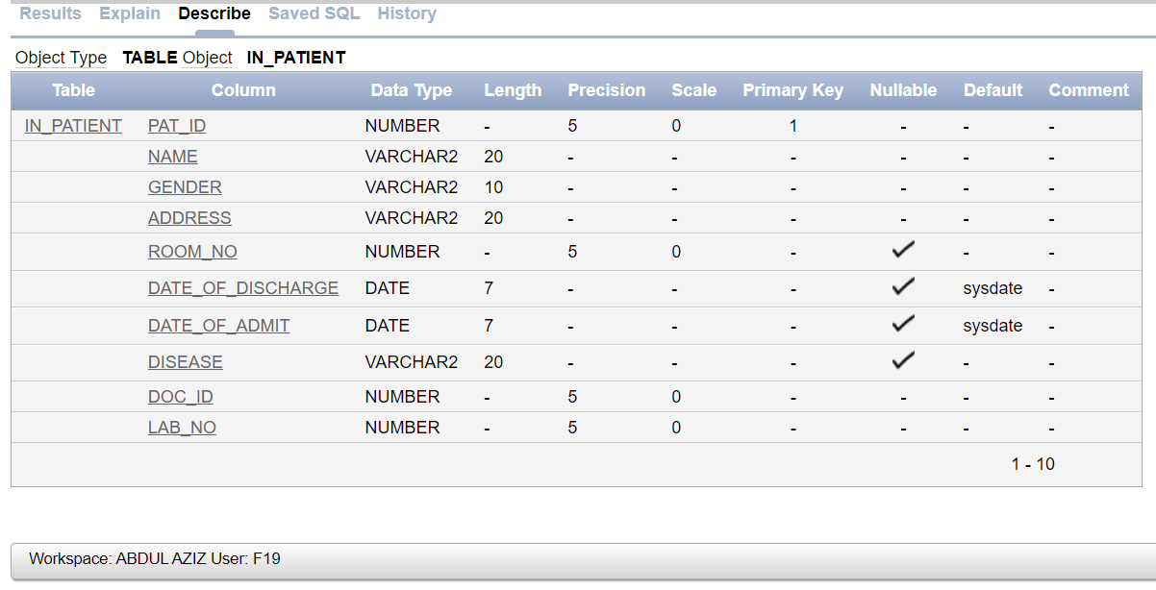
CREATE TABLE ROOM
(
Room_no NUMBER(5),
Room_type varchar(10) NOT NULL,
capacity NUMBER(5) NOT NULL,
constraint R_Room_no_pk primary key (Room_no)
);
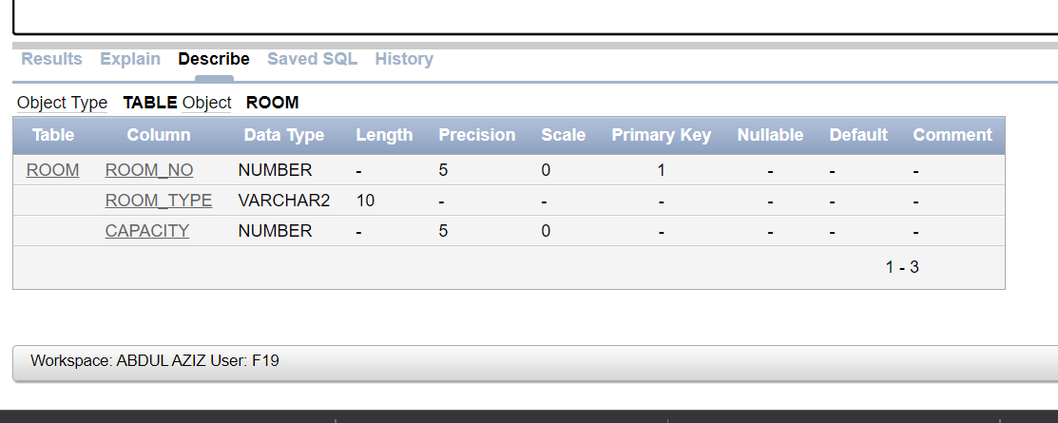
CREATE TABLE BILL
(
Bill_no NUMBER(10),
Pat_ID NUMBER(5) NOT NULL,
Doc_Charges NUMBER(10) NOT NULL,
Pat_type varchar(20) NOT NULL,
Medicine_Charges NUMBER(5),
Operation_Charges NUMBER(5),
Room_charges NUMBER(5),
Nursing_charges NUMBER(5) NOT NULL,
Lab_Charges NUMBER(5) NOT NULL,
Health_Card VARCHAR(50),
constraint BILL_Bill_no_PK PRIMARY KEY (Bill_no),
constraint BILL_Pat_ID_FK FOREIGN KEY (Pat_id) REFERENCES IN_PATIENT (Pat_id)
);
